**SURESH PAWAR**

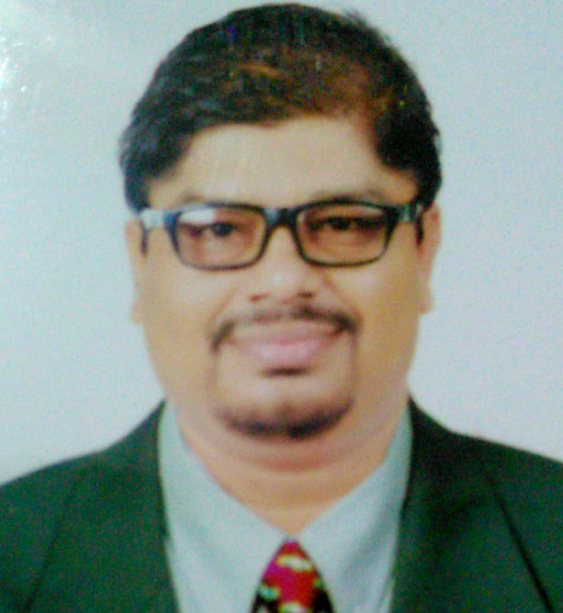**Photograph**

**E-Mail:**suresh227284@gmail.com, suresh227284@yahoo.in

**Phone**: +91-8888995864 / +91-7020108002

**Strategic Planning / Sales and Marketing / Business Development**

**PROFILE SUMMARY**

* An Emerging Markets Master with 12 years experience in Launching new brands in Rural Maharashtra with 5 years exposure of Mumbai Market .
* Visionary Leader & Strategist with **17 years** of experience in Business Development, Sales & Marketing, Retail Sales & Operations, Customer Service Management across FMCG (Dairy Products, Soap), Telecom- Devices- Smartphones with service etc. and General Insurance domains in Indian urban & Emerging markets.
* MBA (Marketing) Professional with comprehensive experience in Channel Management and Key Account Management across multiple categories across the country leading high growth and new brand launches in Emerging and Rural Markets.
* Acknowledged for strengthening companies to lead in highly competitive markets and delivering innovative marketing concepts & strategies
* Proven skills in achieving / exceeding targets, opening new & profitable product/services markets & setting up business operations in untapped markets
* Game changer & strategic business leader with proficiency in executing key business initiatives & strategies, thereby resulting in increase in market share, sales volume & added bottom line
* Expert in strategic forward planning; skilled in operating within tight operational & financial disciplines such as P & L, distribution and business development for reviving / restructuring organizations from germination level
* Articulate, decisive leader, top performing team player & quick learner with detail-oriented approach to manage high team performance through mentoring &problem-solving

**SKILL SET**

**Strategic Sales & Marketing New Business Development Revenue Generation & Profitability**

**Retail Management Modern Trade Sales Brand Building**

**Territory / Channel Management Sales Planning & Promotion Team Management**

**Market Research & Analysis Cost Optimisation Process Improvement**

**P & L Management Staff Training & Development Operations Management**

**Contract Negotiations Infrastructure Management Customer Relationship Management**

**Supply Chain Management Key Account Management Project Management**

**ORGANIZATIONAL EXPERIENCE**

**Since Jan 2019 To Till date Hello Verify India Pvt. Ltd. As West Region Head**

**Key Result Areas:**

* Business Development and Account Management - Proactive prospecting and discovering of potential clients and the appropriate multi-level contact opportunities including prioritization based on company objectives.
* Collaborate with CEO for sales strategy and pricing strategy. Sales Strategy
* Create an effective sales and pipeline strategy and effectively manage the process to create the scale of

opportunities necessary to meet target numbers..

* Build pipeline, create momentum and anticipate industry opportunities and needs Build pipeline, create momentum and anticipate industry opportunities and needs.
* Oversee the development of initiatives for sales opportunities, maximizing revenue and profit levels.
* Demonstrate an understanding of the key performance metrics or KPIs that will be used to measure

performance over time.

* Maintains knowledge of trends, competitive activity market conditions and other relevant data .
* Relationship Management - Drive client communications, service and retention through establishing and growing relationships with top clients and serving as a credible company representative.
* Execute total sales solution efforts by driving creative pricing and bundling of products to maximize client

relationships and build market share

**Highlights:**

* Launched Services in West Region by Onboarding big Clients like Poonawala Group , Edelweiss Group.
* **Achieved 114% Customer Acquisition Targets** Q4-2018-2019 year topping the chart for quality business in india.
* Steered **Acquisition of clients from Untapped Industries like Pharma, Hospitality, Finance & IT Sectors.**
* **Activated old Inactive accounts by resolving issues and assuring services.**

**Since Feb’15 To 25th june 2018 Reliance Jio infocom Ltd., as Jio CenterManager – (JCM) Business Unit Head**

**Key Result Areas:**

* Launching and distributing products with planned BTL activities with consumer and retailer schemes
* Designing successful sales techniques/strategies/tactics using customer and market feedback
* Analysing the client list for growth opportunities; mapping and supervising new sales prospects
* Planning, formulating and implementing marketing strategies and promotions to increase market penetration and to drive revenue and profitability by maximizing sales
* Conceptualising and executing innovative promotions to enhance brand visibility and a suitable media plan, in coordination with the marketing team and external agencies
* Accomplishing and exceeding volume and profit goals by nurturing partnerships with existing customers
* Executing channel sales & distribution strategy to achieve segment-wise targeted sales volumes, state & city-wise market shares, reach and coverage objectives
* Devising trade marketing strategies with focus on achieving defined business objectives across all product categories
* Supervising sales and marketing manpower as well as the hiring and training of personnel

**Nov’09 – Oct’13: ICICI Lombard GIC Ltd., Mumbai as Channel Sales Manager – (Retail sales)**

**Highlights:**

* Dhule Branch was taken from a loss making Branch with 11 lakh revenue to 68 lakh revenue Profitable branch.
* Activated 16 new Channel Partners in Dhule ,Jalgaon and Nandurbar Districts.
* Activated 6 Health Insurance agents Targetting Premium Life insurance Agents .
* Managed a team of 12 personnel; steered the **channel network for Mumbai West region**
* **Tata Jaguar – Landrover was Reactivated with an average Business revenue of 35 lacs/mth**
* **Attained 140%** against the set growth target 2012-13 as well as achieved new channel activation target
* Launched Toyota Insurance with high price and less commission structure in a matured market
* Activated 6 new channels 3 Motor Channel Partners 2 Brokers and one Corporate .
* Minimised the loss ratios by strategically initiating modification labour discounts and OD discounting factor with consistent scrutinisation; developed a strong **dealer / retailer network across Mumbai, Nashik, Dhule, Jalgaon & Nandurbar districts**

**PREVIOUS EXPERIENCE**

**9643970189**

**Sep’08 – Nov’09: Virgin Mobile India Pvt. Ltd., Ahmednagar as Area Sales Manager - Prepaid**

**Highlights:**

* Managed the Distributor and Dealers Network for Ahmednagar district; mentored a team of 22 members
* Received several appreciation mails from the Regional Head for conducting outstanding promotional activities
* Recognised with the **2nd highest rating among all SMs Pan-India;** acknowledged as **Best Performing ASM for 2008**
* **Received Achievement Award** for the month of Oct’08 and Nov’08

**Apr’07 – Aug’08: Idea Cellular Limited, Ahmednagar as Territory Manager - Prepaid**

**Highlights:**

* Conducted **retail expansion from 210 to 1250 outlets** and ensured **distributor expansion from 2 to 16** in the year 2007-08
* Achieved **revenue growth from INR35 Lakhs per month to INR1.9 Crores per month** in the year 2007-08
* Nominated for the **Best Performing TSM Award for FY 2007 – 08**
* Recognised with **Idea Excellence Award** for the month of Nov’07

**Apr’06 - Mar’07: DMML (Cholayil-Medimix Soap), Maharashtraas Sr. Territory Sales Manager**

**Highlights:**

* Managed a team of 4 on role and 10 off role personnel for managing distributor / dealers network In Maharashtra
* **Launched 4 new products** in the assigned territory with exceeding the outlet placement target
* Steered **retail expansion from 6500 to 12000 outlets**; led **distributor expansion from 4 to 12 C&F Agents and 70 to 190 distributors in the year 2006-07**
* **Augmented revenue from INR 75 lakhs per month to INR1.4 crores per month** in the year 2006-07
* Recognised with**Gold Star Award** for consistent performance growth in the assigned territory

**Feb’01 - Mar’06: S.R.T.M.P.P.L. Pune Leading Dairy FMCG Company, Pune as Executive Sales**

**Highlights:**

* **Expanded distributor network from 120 to 350 distributors**until Mar’06
* **Augmented revenues from INR1.1 Crores per month to INR5.2 Crores per month** till the year 2006
* Launched Milk Products Range of 14 products in **retail market across Maharashtra and Gujarat**
* Secured No.1 position for the brand in the assigned segment across Pune Territory and No. 2 position in Vidarbha, Marathwada till Mar’05

**ACADEMIC DETAILS**

* MBA (Marketing) from Amrutwahini Institute of Management & Business Administration, Sangamner (University of Pune) in 2001 with 64.25%
* B.Sc. (Chemistry) from S.M.B.S.T. College, Sangamner (University of Pune) in 1999

**Other Course:**

* DOA & FA (Diploma in Office Automation and Financial Accounting) from Pune (PACE/CDAC) in 2000 with 71% (A Grade)

**PERSONAL DETAILS**

**Date of Birth:**2nd July 1976

**Languages Known:** English, Hindi & Marathi

**Address:** C/O Dattatray Raosaheb Thete, Vishwakarma Colony no. 1,

 Near  Ganesh nagar Gate,

Alandi Road, Bhosari , Pune -411039,